DIGITAL IMAGE PROCESSING
Lung Segmentation chest x-rays
PROJECT REPORT

Submitted by:
Huzaifa Shahbaz
21-CE-009
Aqsa Shah 21-CE-039
Submitted to: MAAM HAREEM KHAN
Department of Computer Engineering,
HITEC University, Taxila

Table of Contents
CHAPTER#1 ABSTRACT 6
1.1 ABSTRACT: 6
CHAPTER#2 INTRODUCTION 6
2.1INTRODUCTION: 6
CHAPTER#3 OBJECTIVES 7
3.1OBJECTIVES: 7
CHAPTER#4 PROBLEM STATEMENT 8
4.1PROBLEM STATEMENT: 8
CHAPTER#5 METHODOLOGY 8
5.1METHODOLOGY: 8
CHAPTER#6 COMPONENTS USED 9
6.1 COMPONENTS USED: 9
CHAPTER#7 FUNCTIONAL REQUIREMENTS 9
7.1 FUNCTIONAL REQUIREMENTS: 9
7.1.1 IMAGE ACQUISITION: 9
7.1.2 PREPROCESSING: 9
7.1.3 LUNG SEGMENTATION: 9
7.1.4 EDGE DETECTION: 10
7.1.5 FEATURE EXTRACTION: 10
7.1.6 ACCURACY MERTICS: 10
7.1.7 INTEGRATION WITH DIAGNOSTIC TOOLS: 10
7.1.8 VISUALIZATION: 10
7.1.9 COMPATIBILITY AND SCALABILITY: 10
7.1.10 ERROR REPORTING: 10
CHAPTER#8 NON- FUNCTIONAL REQUIREMENTS 11
8.1 NON- FUNCTIONAL REQUIREMENTS: 11
8.1.1 PERFORMANCE: 11
8.1.2 ACCURACY AND PRECISION: 11
8.1.3 RELIABILITY: 11
8.1.4 SCALABILITY: 11
8.1.5 USABILITY: 11
8.1.6 SECURITY: 12
8.1.7 COMPATIBILITY: 12
8.1.8 MAINTAINABILITY: 12
8.1.9 INTERPREABILITY: 12
8.1.10 ENERGY EFFICIENCY: 12
CHAPTER#9 TECHNIQUES OF LUNG SEGMENTATION CHEST X-RAYS 13
9.1 TECHNIQUES OF LUNG SEGMENTATION CHEST X-RAYS: 13
9.2 PREPROCESSING: 13
9.2.1 NOISE REMOVAL: 13
9.2.2 HISTOGRAM EQUALIZATION: 13
9.2.3 NORMALIZATION: 13
9.2.4 BONE SUPPRESSION: 13
9.3 THRESHOLDING: 14
9.3.1 GLOBAL THRESHOLDING: 14
9.3.2 ADAPTIVE THRESHOLDING: 14
9.4 EDGE DETECTION: 14
9.4.1 CANNY EDGE DETECTION: 14
9.4.2 SOBEL FILTER: 14
9.4.3 PREWITT FILTER: 14
9.5 MORPHOLOGICAL OPERATIONS: 14
9.5.1 DILATION AND EROSION: 14
9.5.2 OPENING AND CLOSING: 15
CHAPTER#10 CODES OF LUNG SEGMENTATION CHEST X-RAYS 15
10.1 CODES OF LUNG SEGMENTATION CHEST X-RAYS: 15
10.1.1 PYTHON CODE OF LUNG SEGMENTATION CHEST X-RAYS: 15
10.1.2 MATLAB CODE OF LUNG SEGMENTATION CHEST X-RAYS: 19
CHAPTER#11 OUTPUTS OF LUNG SEGMENTATION CHEST X-RAYS 23
11.1 OUTPUTS OF LUNG SEGMENTATION CHEST X-RAYS: 23
11.2 PYTHON OUTPUT OF LUNG SEGMENTATION CHEST X-RAYS: 24
11.1.2 MATLAB OUTPUT OF LUNG SEGMENTATION CHEST X-RAYS: 25
CHAPTER#12 APPLICATION AND USES OF LUNG SEGMENTATION CHEST X-RAYS 25
12.1 APPLICATION AND USES OF LUNG SEGMENTATION CHEST X-RAYS: 25
12.2 DISEASE DETECTION AND DIAGNOSIS: 25
12.3 TREATMENT PLANNING AND MONITORING: 26
12.4 COMPUTER AIDED-DESIGN: 26
12.5 PULMONARY FUNCTION ANALYSIS: 26
12.6 MEDICAL IMAGE REGISTERATION: 26
12.7 DETECTION OF AIR TAPPING AND FLUID ACCUMULATION: 27
12.8 PUBLIC HEALTH AND RESEARCH: 27
12.9 EDUCATION TOOLS: 27
CHAPTER#13 CONCLUSION 27
13.1 CONCLUSION: 27

CONTENTS OF FIGURES
Figure 11.1.1:OUTPUT OF LUNG SEGMENTATION OF CHEST X-RAYS 24
Figure 11.1.2:TEMPERATURE X-RAYS OF LUNG SEGMENTATION CHEST X-RAYS BY USING PYTHON 24
Figure 11.1.3:MATLAB OUTPUT OF LUNG SEGMENTATION CHEST X-RAYS 25

CHAPTER#1 ABSTRACT

1.1 ABSTRACT:
Image analysis of the chest X-rays would include an accurate segmentation of the lungs for the capturing of early detection and diagnosis of respiratory diseases such as pneumonia and tuberculosis and also lung cancers. This project is thus, aimed at developing very efficient lung segmentation for digital image processing techniques. The primary objective of lung segmentation is improving the efficiency of medical imaging by giving the possibility of isolating lung regions on chest X-ray images so that they can be analyzed further by health care professions. The whole process starts with pre-processing like denoising, and enhancement of the contrast, followed by the application of known edge detection techniques for lung boundary identification. After thresholding and morphological operations, the results are used for final segmentation of the images, which is the determination that lung areas are accurately segmented. This method is tested on a public database of chest X-ray images, and the performance is evaluated using measures such as accuracy, sensitivity, and specificity to compare the methods involved. The project is also aimed at automating medical images for faster, more accurate diagnosis of lung problems.

CHAPTER#2 INTRODUCTION

2.1INTRODUCTION:
Medical imaging is an urgent and significant specialty that has access to chest X-rays for diagnosing and monitoring several diseases of the lungs, including pneumonia, tuberculosis, lung cancer, and COPD. It has a non-invasive feature coupled with low-cost pricing and high availability. Unfortunately, the manual interpretation of radiologists ends up becoming highly time-consuming and error-prone, especially in those resource-poor settings. One essential step, lung segmentation, is to isolate the areas of lungs from surrounding structures like the ribcage and heart and is crucial for the automated interpretation of chest X-rays. The importance of accurate segmentation ranges from disease detection, feature extraction, as well as volume calculations. Hence, this work presents an automated lung segmentation pipeline involving image processing techniques such as enhancement, edge detection, and morphological operations to improve diagnostic accuracy and help healthcare workers.

CHAPTER#3 OBJECTIVES

3.1OBJECTIVES:
1.Learn some basic that are concerned with the digital image processing techniques related to medical imaging and lung segmentation.
2.Analyze different publicly available chest X-ray datasets for better understanding variability in images and the challenges to segmentation in the lung region.
3.Create an automatic method for lung segmentation using methods such as image pre-processing, edge detection, and morphological operations.
4.Implement and evaluate the methods of segmentation accuracy, sensitivity, and specificity against the known ground-truth data.
5.Compare the performance between the developed method with the existing lung segmentation methods to assess the efficiency and reliability of the method.
6.Optimize the algorithm with respect to robustness and scalability for further integration with a CAD system in lung disease detection.

CHAPTER#4 PROBLEM STATEMENT

4.1PROBLEM STATEMENT:
It's an extremely critical and challenging a task in medical imaging to segment the lung regions accurately as well as employ the best methodologies on chest X-rays. Manual lung segmentation is definitely time-consuming, subjective, and impassive to variability when performed by radiologists, especially in complex pathological patterns. The existing automated procedures have limitations such as low contrast in the relevant image, some overlapping structures within the anatomy, and a high degree of similarity between different shapes and sizes of lungs with respect to an image capture. All these factors severely affect the operation of such systems in the computer-aided diagnosis (CAD) of lung diseases, thus creating a dire need for a strong and automated lung segmentation method developed through modern digital image processing techniques to improve diagnostic accuracy and lessen the load on the operating personnel.

CHAPTER#5 METHODOLOGY

5.1METHODOLOGY:
The process of developing a lung segmentation algorithm involves several steps. First, a publicly available chest X-ray dataset is collected, labeled ground truth masks are used for evaluation. Pre-processing techniques like histogram equalization and noise reduction are applied to enhance image contrast. Lung region detection is done using edge detection techniques and region-based segmentation methods. Morphological operations are used to refine the segmented regions and smooth lung contours. Post-processing removes false positives and enhances segmentation results using shape-based constraints. Performance metrics like Dice coefficient, Intersection over Union (IoU), sensitivity, and specificity are used to evaluate the method. The algorithm is then implemented in a digital image processing tool and optimized for speed and scalability. Results are analyzed to determine the algorithm's effectiveness and compared with existing lung segmentation techniques to assess improvements.

CHAPTER#6 COMPONENTS USED

6.1 COMPONENTS USED:
1.MATLAB
2.PYTHON

CHAPTER#7 FUNCTIONAL REQUIREMENTS

7.1 FUNCTIONAL REQUIREMENTS:
The functional requirements of lung segmentation chest x-rays are:

7.1.1 IMAGE ACQUISITION:
The chest X-ray images need to be accepted by the system in standard formats like DICOM, PNG, or JPEG.

7.1.2 PREPROCESSING:
Image preprocessing techniques should include normalization, contrast enhancement, and noise reduction to improve segmentation accuracy.

7.1.3 LUNG SEGMENTATION:
The system must make the accurate identification and segmentation of lung regions using AI/ML approaches such as U-Net, Mask R-CNN, or DeepLabV3+.

7.1.4 EDGE DETECTION:
The edges in the regions of the lungs should be demarcated by the application of the edge-detection algorithms into the system.

7.1.5 FEATURE EXTRACTION:
Extract features like shape, size, and texture for further analysis or diagnosis.

7.1.6 ACCURACY MERTICS:
Segmentation accuracy is to be computed by such metrics as Dice Coefficient, Intersection over Union (IoU), and Sensitivity.

7.1.7 INTEGRATION WITH DIAGNOSTIC TOOLS:
The segmented lung parts must be compatible with diagnostic systems for further analyses such as finding conditions like pneumonia, tuberculosis, or lung cancer.

7.1.8 VISUALIZATION:
Specify a visualization of overlaid segmented lung regions for the purpose of aiding the radiologists in verifying the segmentation results.

7.1.9 COMPATIBILITY AND SCALABILITY:
It ought to be incorporated into Picture Archiving and Communication Systems (PACS) and should relatively have the scope to scale large data sets.

7.1.10 ERROR REPORTING:
The system is intended to log failed or intervention-required cases at the time of segmentation for increased improvements.

CHAPTER#8 NON- FUNCTIONAL REQUIREMENTS

8.1 NON- FUNCTIONAL REQUIREMENTS:
The non-functional requirements of lung segmentation chest x-rays are:

8.1.1 PERFORMANCE:
In order to ensure real-time usability in clinical settings, it should process each chest X-ray within 2-3 seconds.

8.1.2 ACCURACY AND PRECISION:
The AI system has a speculative possibility that one day it will segment is tracks with at least 95% Dice Similarity Coefficient which is required for clinical diagnosis.

8.1.3 RELIABILITY:
The system must be functional and run constantly for 99.9% of the time, even for unforeseen situations such as receiving cut and corrupt X-ray images without crashing.

8.1.4 SCALABILITY:
There must be the optimum scaling of the system so that it can manage even vast amounts of data like 1 million X-rays but do ensure that performance should remain same.

8.1.5 USABILITY:
It should be a friendly interface that would need to give limited training to radiologists and other healthcare staff on navigating and using it.

8.1.6 SECURITY:
Standard compliance with either the HIPAA or the GDPR specification is required to safeguard the patients' data, such as X-rays, with respect to their confidentiality.

8.1.7 COMPATIBILITY:
The system should easily integrate into the infrastructures of the hospitals, including Electronic Health Records (EHRs) and Picture Archiving and Communication Systems (PACS).

8.1.8 MAINTAINABILITY:
The system architecture must be amenable to modification and enhancement so as to remain compatible with future image development technologies.

8.1.9 INTERPREABILITY:
Thus, the system would be generating reports justifying the segmentation results so that the radiologists could verify the output.

8.1.10 ENERGY EFFICIENCY:
It is preferable for the system to minimize energy consumption in order to make sustainability available, particularly in the case of cloud computing.

CHAPTER#9 TECHNIQUES OF LUNG SEGMENTATION CHEST X-RAYS

9.1 TECHNIQUES OF LUNG SEGMENTATION CHEST X-RAYS:
Lung segmentation in chest X-ray images is an extremely competitive field of medical image analysis, majorly used for the diagnosis and follow-up of respiratory diseases like tuberculosis, pneumonia, or COVID-19. Here's an overview of the various digital image processing techniques adopted for lung segmentation:

9.2 PREPROCESSING:
The objective of preprocessing is to improve the image quality and prepare it for segmentation. The common steps include:

9.2.1 NOISE REMOVAL:
Utilize Gaussian or median filters in order to suppress noise.

9.2.2 HISTOGRAM EQUALIZATION:
Enhances the contrast in the X-ray image.

9.2.3 NORMALIZATION:
Here scales pixel intensity values to certain ranges (for example, [0,1]).

9.2.4 BONE SUPPRESSION:
It improves soft tissues while diminishing the visibility of bones.

9.3 THRESHOLDING:

9.3.1 GLOBAL THRESHOLDING:
Establishes a general intensity threshold to segregate lungs from the background.

9.3.2 ADAPTIVE THRESHOLDING:
Dynamically adjusts threshold over the complete image for improved segmentation.

9.4 EDGE DETECTION:
The paragraph gives full description of how to demarcate the lung borders.

9.4.1 CANNY EDGE DETECTION:
Multi-stage edge detection is done for high precision.

9.4.2 SOBEL FILTER:
The calculation of gradients into images emphasizes the adjoining edges in two-dimensional images.

9.4.3 PREWITT FILTER:
The Sobel filter is an easier method than the conventional filter.

9.5 MORPHOLOGICAL OPERATIONS:
This shortens the time of developing a tool useful in enhancing accuracy in segmentation results.

9.5.1 DILATION AND EROSION:
It will fill out holes or smooth edges within lung surfaces.

9.5.2 OPENING AND CLOSING:
Lung region removal of small objects or holes.

CHAPTER#10 CODES OF LUNG SEGMENTATION CHEST X-RAYS

10.1 CODES OF LUNG SEGMENTATION CHEST X-RAYS:
In this project we use the python and MATLAB to demonstrate the working function of the lung segmentation chest x-rays.

10.1.1 PYTHON CODE OF LUNG SEGMENTATION CHEST X-RAYS:
import cv2
import numpy as np
import matplotlib.pyplot as plt
from skimage import exposure
from scipy import ndimage
def preprocess_image(image):
"""Convert image to grayscale and float32 format"""
if len(image.shape) == 3:
image = cv2.cvtColor(image, cv2.COLOR_BGR2GRAY)
return np.float32(image)
def remove_noise(image, kernel_size=5):
"""Apply noise removal techniques"""
denoised = cv2.GaussianBlur(image, (kernel_size, kernel_size), 0)
denoised = cv2.medianBlur(denoised.astype(np.uint8), kernel_size)
return np.float32(denoised)
def enhance_contrast(image):
"""Apply CLAHE enhancement"""
clahe = cv2.createCLAHE(clipLimit=2.0, tileGridSize=(8,8))
clahe_eq = clahe.apply(image.astype(np.uint8))
return np.float32(clahe_eq)
def normalize_image(image):
"""Normalize image to 0-1 range"""
normalized = cv2.normalize(image, None, 0, 255, cv2.NORM_MINMAX)
return normalized
def detect_edges(image):
"""Apply Canny edge detection"""
edges = cv2.Canny(image.astype(np.uint8), 50, 150)
return edges
def apply_morphological_operations(image):
"""Apply morphological operations"""
kernel = np.ones((5,5), np.uint8)
dilated = cv2.dilate(image.astype(np.uint8), kernel, iterations=1)
eroded = cv2.erode(image.astype(np.uint8), kernel, iterations=1)
return dilated, eroded
def process_and_display_xray(image_path):
# Read image
image = cv2.imread(image_path)
if image is None:
raise ValueError("Could not read the image")
# Process image
preprocessed = preprocess_image(image)
denoised = remove_noise(preprocessed)
enhanced = enhance_contrast(denoised)
normalized = normalize_image(enhanced)
edges = detect_edges(normalized)
dilated, eroded = apply_morphological_operations(normalized)
# Create figure for visualization
plt.figure(figsize=(20, 10))
# Original
plt.subplot(231)
plt.imshow(preprocessed, cmap='gray')
plt.title('Original Grayscale')
plt.axis('off')
# Denoised
plt.subplot(232)
plt.imshow(denoised, cmap='gray')
plt.title('Denoised')
plt.axis('off')
# Enhanced
plt.subplot(233)
plt.imshow(enhanced, cmap='gray')
plt.title('CLAHE Enhanced')
plt.axis('off')
# Normalized
plt.subplot(234)
plt.imshow(normalized, cmap='gray')
plt.title('Normalized')
plt.axis('off')
# Edges
plt.subplot(235)
plt.imshow(edges, cmap='gray')
plt.title('Canny Edges')
plt.axis('off')
# Morphological
plt.subplot(236)
plt.imshow(dilated, cmap='gray')
plt.title('Dilated')
plt.axis('off')
plt.tight_layout()
plt.show()
return {
'preprocessed': preprocessed,
'denoised': denoised,
'enhanced': enhanced,
'normalized': normalized,
'edges': edges,
'dilated': dilated,
'eroded': eroded
}
# Run the processing
try:
# Save the current image as a temporary file
cv2.imwrite('temp_xray.jpg', cv2.imread('LUNGSEGMENTATIONCHESTX-RAYS.jpg'))
# Process the image
results = process_and_display_xray('temp_xray.jpg')
print("Processing completed successfully!")
except Exception as e:
print(f"An error occurred: {str(e)}")

10.1.2 MATLAB CODE OF LUNG SEGMENTATION CHEST X-RAYS:
clc;
clear;
close all;
% Load the image
% Read the input image
img = imread('chest_xray.jpg');
if size(img, 3) > 1
img = rgb2gray(img);
end
img = im2double(img);
% Preprocessing and Noise Removal
% Apply Gaussian filter for noise reduction
img_denoised = imgaussfilt(img, 2);
% Histogram Equalization
img_histeq = adapthisteq(img_denoised);
% Normalization
img_normalized = (img_histeq - min(img_histeq(:))) / (max(img_histeq(:)) - min(img_histeq(:)));
% Bone Suppression using morphological operations
se_bone = strel('disk', 15);
background = imopen(img_normalized, se_bone);
img_bone_suppressed = img_normalized - background;
% Global Thresholding
level = graythresh(img_bone_suppressed);
img_global_thresh = imbinarize(img_bone_suppressed, level);
% Adaptive Thresholding
img_adaptive_thresh = imbinarize(img_bone_suppressed, 'adaptive', 'Sensitivity', 0.4);
% Edge Detection using different methods
% Canny Edge Detection
img_canny = edge(img_bone_suppressed, 'Canny');
% Sobel Filter
img_sobel = edge(img_bone_suppressed, 'Sobel');
% Prewitt Filter
img_prewitt = edge(img_bone_suppressed, 'Prewitt');
% Morphological Operations
se = strel('disk', 3);
% Dilation
img_dilated = imdilate(img_adaptive_thresh, se);
% Erosion
img_eroded = imerode(img_adaptive_thresh, se);
% Opening (Erosion followed by Dilation)
img_opened = imopen(img_adaptive_thresh, se);
% Closing (Dilation followed by Erosion)
img_closed = imclose(img_adaptive_thresh, se);
% Display results
figure('Position', [100 100 1200 800]);
subplot(4,4,1), imshow(img), title('Original Image')
subplot(4,4,2), imshow(img_denoised), title('Denoised')
subplot(4,4,3), imshow(img_histeq), title('Histogram Equalized')
subplot(4,4,4), imshow(img_normalized), title('Normalized')
subplot(4,4,5), imshow(img_bone_suppressed), title('Bone Suppressed')
subplot(4,4,6), imshow(img_global_thresh), title('Global Threshold')
subplot(4,4,7), imshow(img_adaptive_thresh), title('Adaptive Threshold')
subplot(4,4,8), imshow(img_canny), title('Canny Edge')
subplot(4,4,9), imshow(img_sobel), title('Sobel Edge')
subplot(4,4,10), imshow(img_prewitt), title('Prewitt Edge')
subplot(4,4,11), imshow(img_dilated), title('Dilated')
subplot(4,4,12), imshow(img_eroded), title('Eroded')
subplot(4,4,13), imshow(img_opened), title('Opened')
subplot(4,4,14), imshow(img_closed), title('Closed')
% Save processed images
imwrite(img_denoised, 'denoised.png');
imwrite(img_histeq, 'histogram_equalized.png');
imwrite(img_normalized, 'normalized.png');
imwrite(img_bone_suppressed, 'bone_suppressed.png');
imwrite(img_global_thresh, 'global_threshold.png');
imwrite(img_adaptive_thresh, 'adaptive_threshold.png');
imwrite(img_canny, 'canny_edge.png');
imwrite(img_sobel, 'sobel_edge.png');
imwrite(img_prewitt, 'prewitt_edge.png');
imwrite(img_dilated, 'dilated.png');
imwrite(img_eroded, 'eroded.png');
imwrite(img_opened, 'opened.png');
imwrite(img_closed, 'closed.png');

CHAPTER#11 OUTPUTS OF LUNG SEGMENTATION CHEST X-RAYS

11.1 OUTPUTS OF LUNG SEGMENTATION CHEST X-RAYS:
In this section we show the result of the lung segmentation chest x-ray by coding python and matlab. First, we show the results in python and after that we show the results in matlab.

11.2 PYTHON OUTPUT OF LUNG SEGMENTATION CHEST X-RAYS:
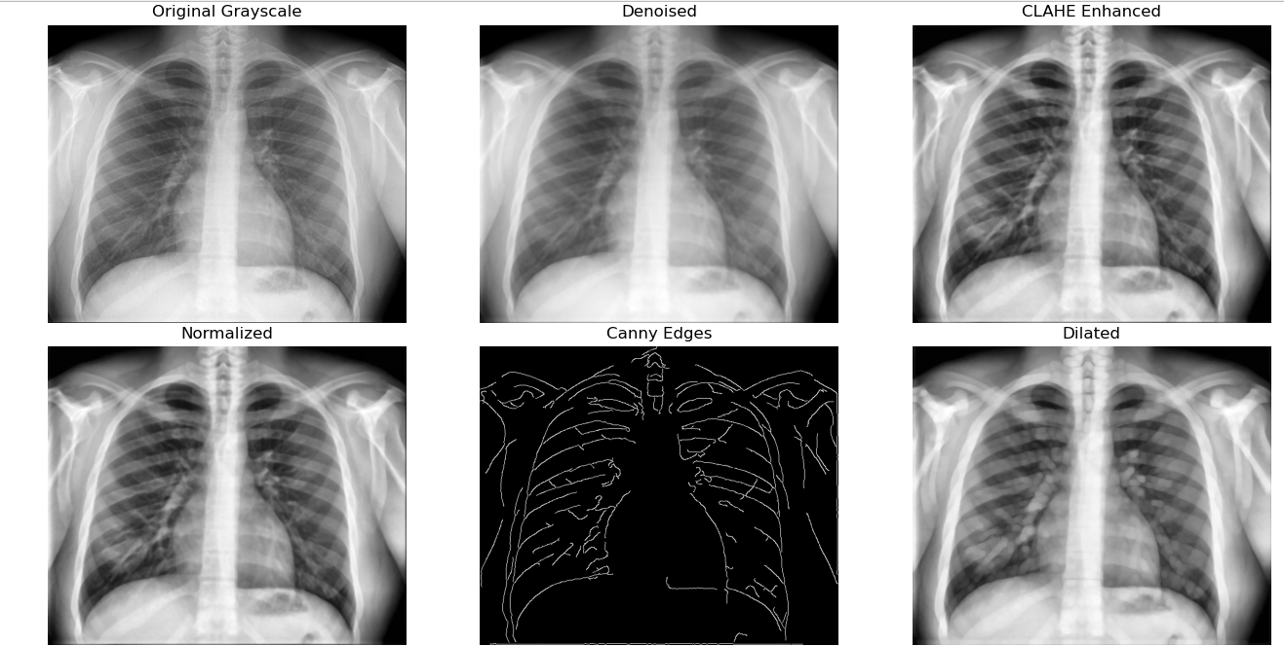
Figure 11.1.1:OUTPUT OF LUNG SEGMENTATION OF CHEST X-RAYS
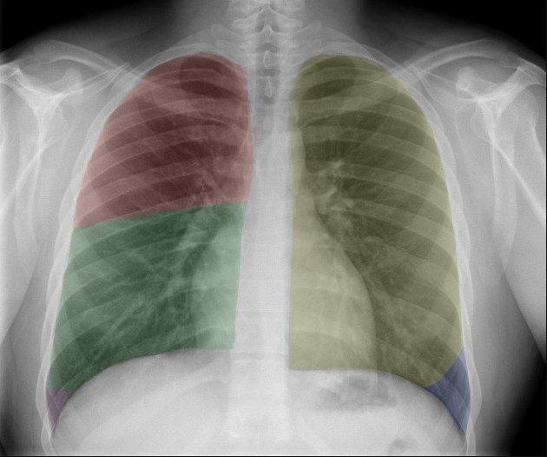
Figure 11.1.2:TEMPERATURE X-RAYS OF LUNG SEGMENTATION CHEST X-RAYS BY USING PYTHON

11.1.2 MATLAB OUTPUT OF LUNG SEGMENTATION CHEST X-RAYS:
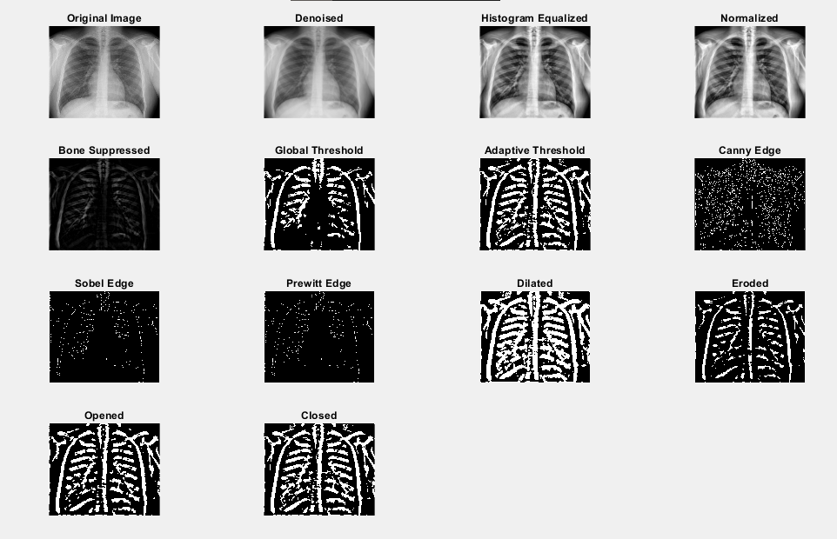
Figure 11.1.3:MATLAB OUTPUT OF LUNG SEGMENTATION CHEST X-RAYS

CHAPTER#12 APPLICATION AND USES OF LUNG SEGMENTATION CHEST X-RAYS

12.1 APPLICATION AND USES OF LUNG SEGMENTATION CHEST X-RAYS:
Now we discuss the applications and uses of lung segmentation chest x-rays of digital image processing of our project.

12.2 DISEASE DETECTION AND DIAGNOSIS:
Through segmentation of lungs, paths are paved for the accurate detection of diseases like pneumonia, tuberculosis, lung cancer, and COVID-19, by separating the lung regions and observing pathological patterns. Segmentation also augments the automated performance in detecting abnormalities such as nodules, lesions, and consolidations.

12.3 TREATMENT PLANNING AND MONITORING:
Radiology evaluation would help assess the degree to which a disease has progressed; any observed changes could be due to tumor growth or spread of infection. It is suited for quantitative analysis to assess the outcome of treatment on lungs through time for conditions affecting the lungs.

12.4 COMPUTER AIDED-DESIGN:
Augments the CAD systems by focusing segmented lung regions and reducing noise from other surrounding anatomy. It plays a constructive role in perfecting the input from deep learning models for better accuracy of diagnostic tools.

12.5 PULMONARY FUNCTION ANALYSIS:
Lung segmentation is very important when it comes to the analysis size, shape, and volume of the lungs, which is useful for the diagnosis of restrictive and obstructive pulmonary diseases.

12.6 MEDICAL IMAGE REGISTERATION:
These can align images from different modalities for the entire view of lung structures, supporting accurate diagnosis and surgical planning.

12.7 DETECTION OF AIR TAPPING AND FLUID ACCUMULATION:
It identifies such abnormal air or fluid accumulation within the lungs which is a necessity for diagnosis for example, pleural effusion or even emphysema.

12.8 PUBLIC HEALTH AND RESEARCH:
Provides an efficient means of analyzing lung X-rays, thus reducing the time and effort needed to diagnose over large populations, while also taking on a much larger role in epidemiological studies.

12.9 EDUCATION TOOLS:
Provides important base resources in medical education and training to understand adult lung anatomy and associated pathologies via visual segmentation.

CHAPTER#13 CONCLUSION

13.1 CONCLUSION:
In conclusion, we implement our project lung segmentation chest x-rays of digital image processing by using two coding languages such as python and matlab. The techniques we used in our project are preprocessing, noise removal, histogram equalization, normalization, bone suppression, thresholding, global thresholding, adaptive thresholding, edge detection, canny edge detection, sobel filter, prewitt filter, morphological operations, dilation and erosion and opening and closing.

